**Contents**

Introduction……………………………………………………………………….

Team Members………………………………………………………………….

Roles………………………………………………………………………………….

Gantt Chart…………………………………………………………………………

Main Work Screenshots…………………………………………………….

Conclusion………………………………………………………………………….

## 

## **INTRODUCTION**

With the help of agile mythology, we create an android application on Expense Controller App. Firstly, user must create an account for run the application after login the user can easily construct its expense category and save his/her expense details on regular bases. User can also view Summary report of Expense based upon month and year wise. This application is multiuser with CRUD operations.

# **TEAM MEMBERS**

**1.Kulwinder**

**2.Lovepreet**

**3.Khushbaz**

## **ROLES**

**Kulwinder**: Product Owner

**Lovepreet** : Scrum Master and Stakeholder

**Khushbaz**: Developer

## **GANTT CHART**

## **Main Work** **SCREENSHOT**

Category Table Screen Shot

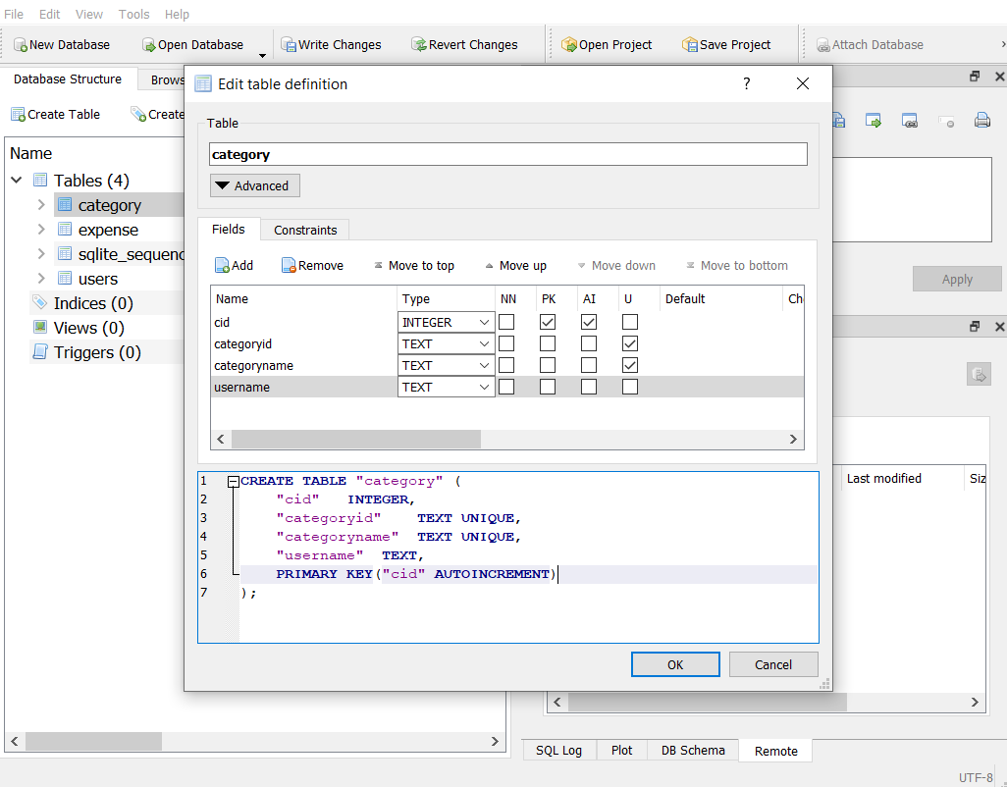

Users Table Screen Shot

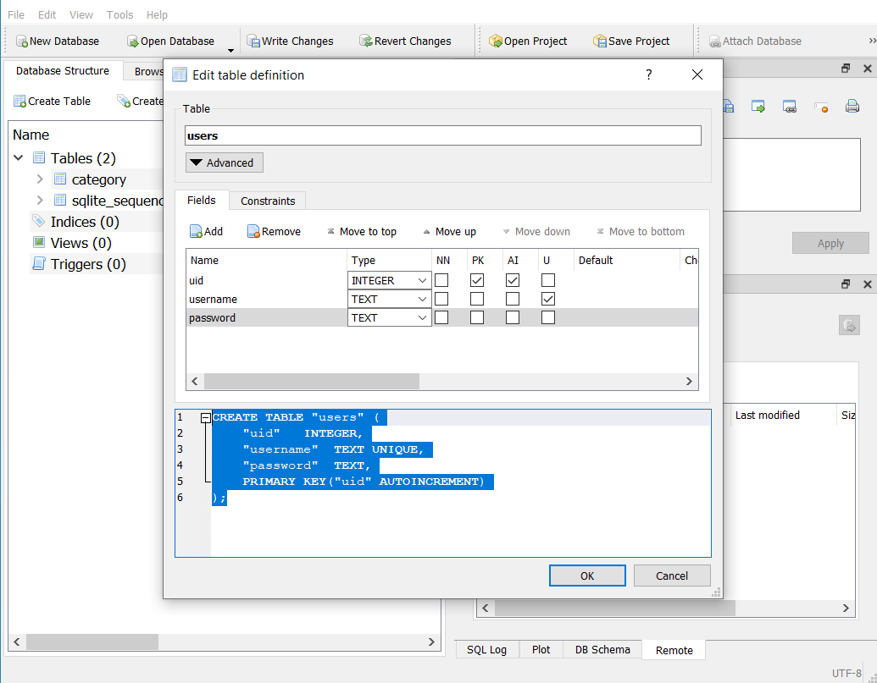

Expense Table Screen Shot

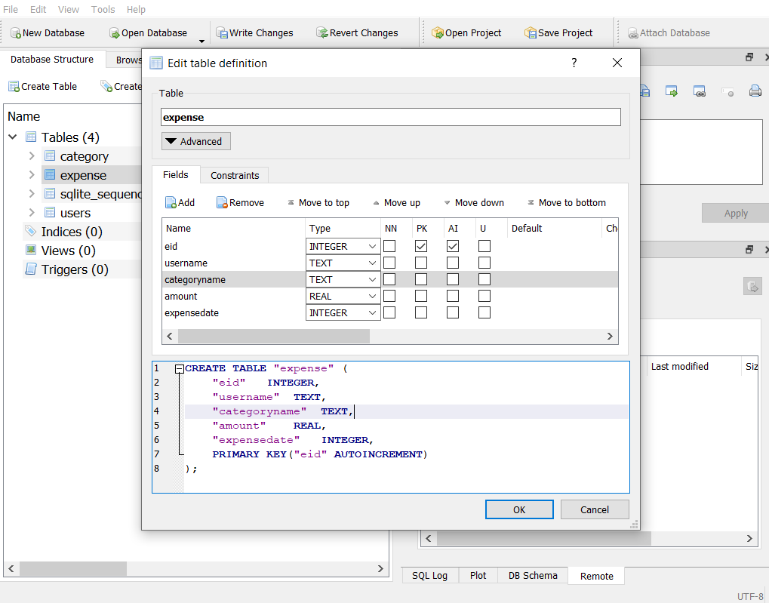

Registration Screen:

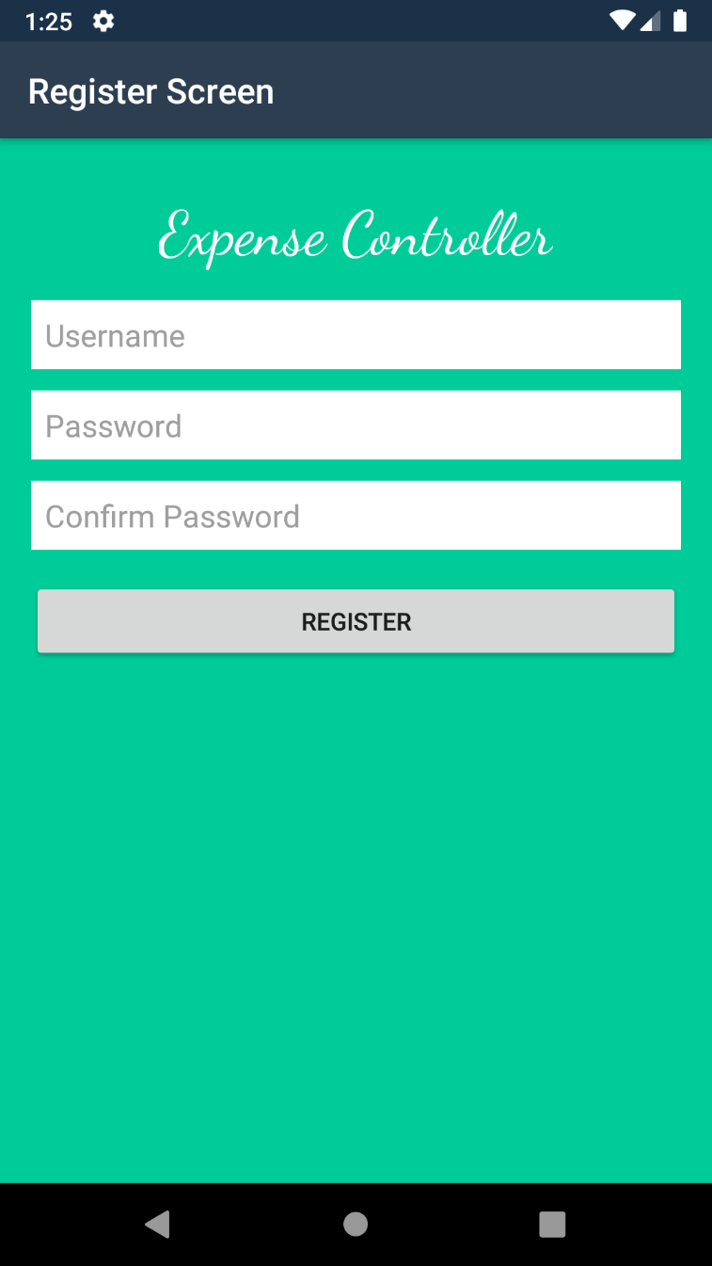

Home Screen:

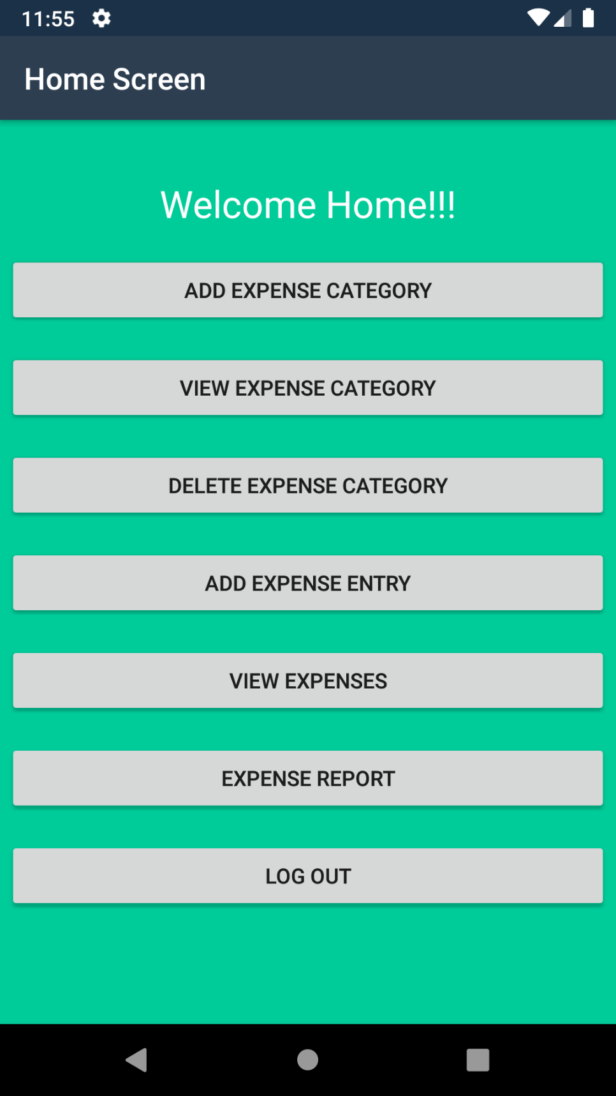

Add Expense Category Screen:

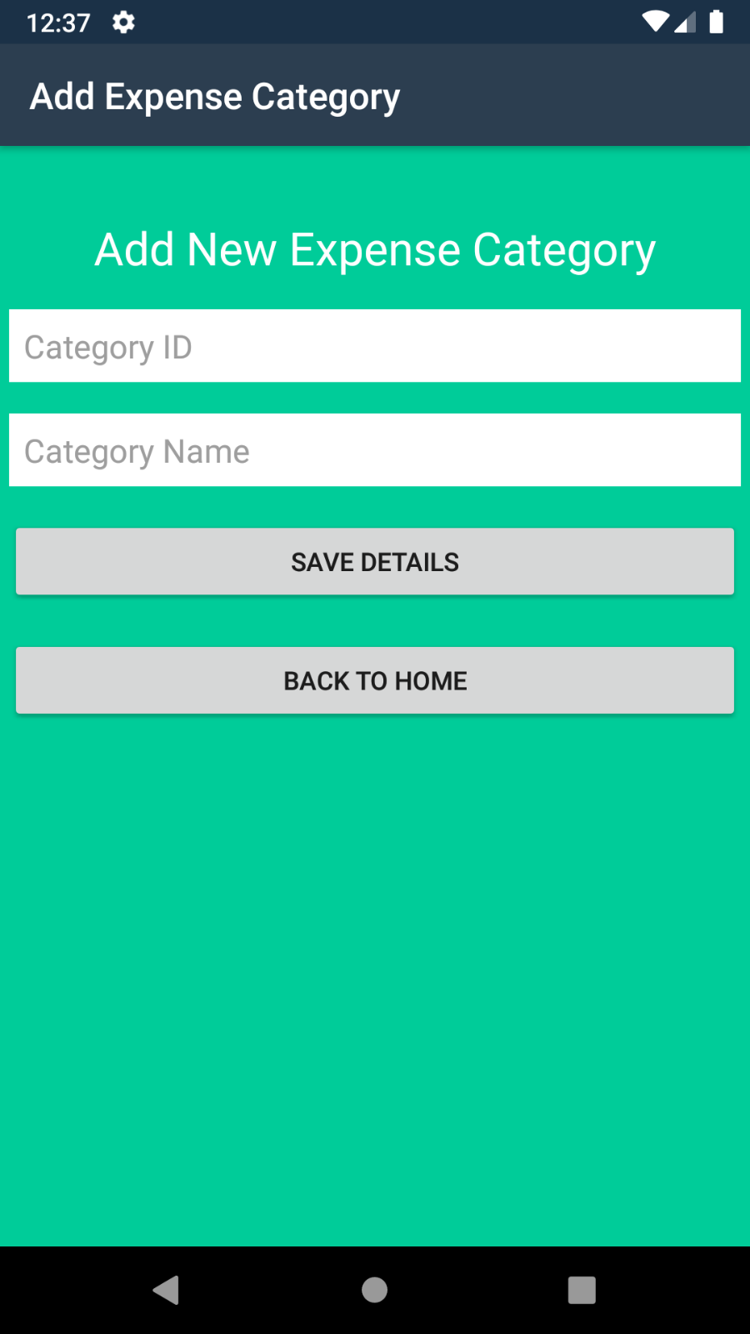

Delete Expense Category Screen:

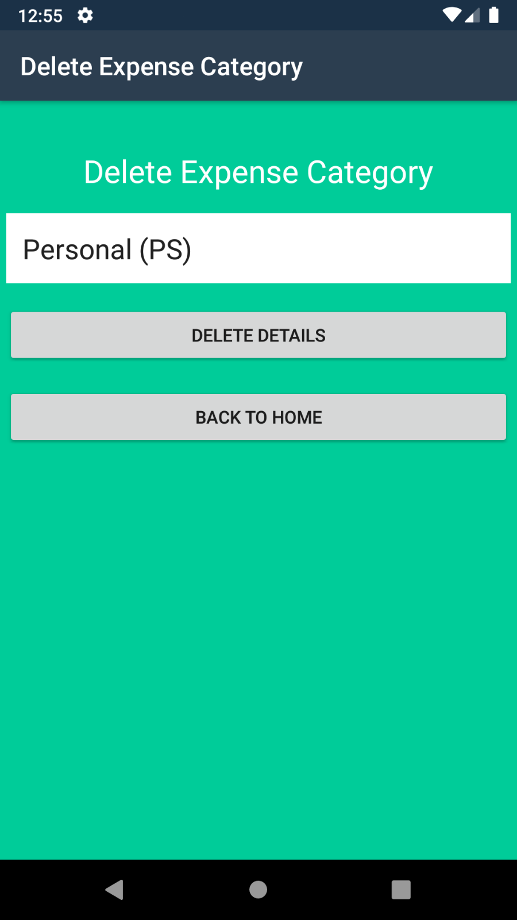

View Expense Category:

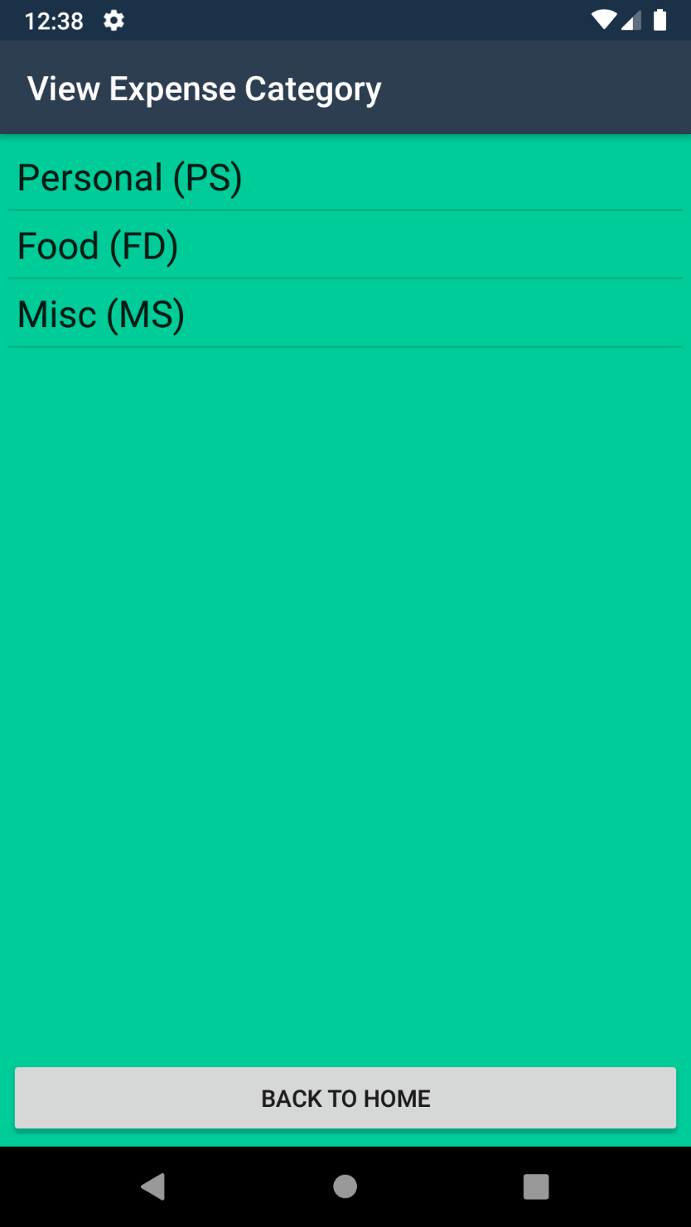

Add Expense Screen:

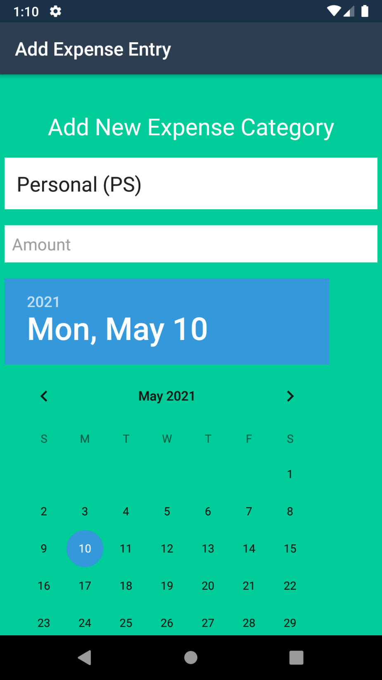

## **Conclusion**

Agile and scrum methodology are used by the project managers for keeping the track of work. As it quickly reacts to changes and is more flexible as compared to others.

To sum up, this application is for the user to register their details and maintain his/her daily expenses at ease of their fingerprint. If this application get chance to interact in market this will be suitable for the target audience and fulfil its main purpose.